**AWS Developer : Designing and Developing on AWS**

Cloud development decisions

* Computing : EC2 or Lambda
* Persistence : S3, Elastic cache, RDS, DynamoDB
* Routing : API Gateway or route 53 DNS

Service Domains in AWS

* Compute - Runs code that you provide
  + Services : EC2, Lambda, Elastic Beanstalk, Batch
* Storage: Store Data
  + Service : S3, Elastic file system(EFS), Glacier, Storage Gateway
* DB : Provides database
  + Services : RDS, DynamoDB, Elastic cache, Amazon Document DB.
* Networking and content delivery: Controls networking and routing
  + Services: VPC, Cloud front, API gateway, Route53
* Developer tool : Facilitates development lifecycle
  + Services: Codestar, codecommit, codebuild, codedeploy, code pipeline, X-ray
* Management and Governance :Service management and orchestration
  + Service : Cloudwatch, Cloud formation, Cloud trail
* Security, identity and compliance : Manages service access
  + Service : IAM , certificate manager
* Analytics: Consumes and processes data
  + Services: redshift, Elastic map reduce(EMR), Opensearch, datapipeline
* Application integration : Integrate AWS
  + Service : SNS, Simple Queue service, Simpleworkflow(SWF), Step functions

**Preparing for AWS certification**

* Knowledge of aws service
* options and details of each service
* different problems and scenarios when using each service

**AWS Budget:** Alerts you when your aws resources charges reach a certain amount.

Monitor billing in AWS

* **Before:** cloud watch alarms
* **Now:** Cloudwatch alarms and aws budgets

Create a Budget

Aws budget --> create budget

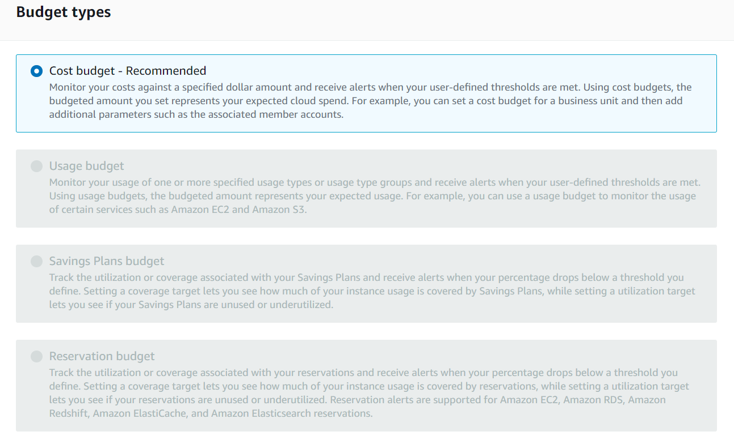

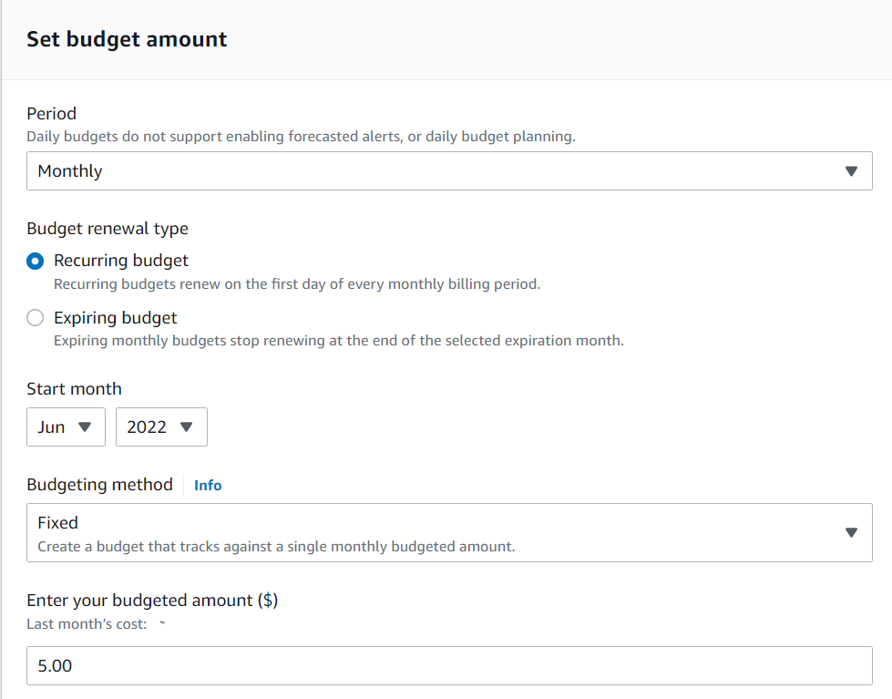

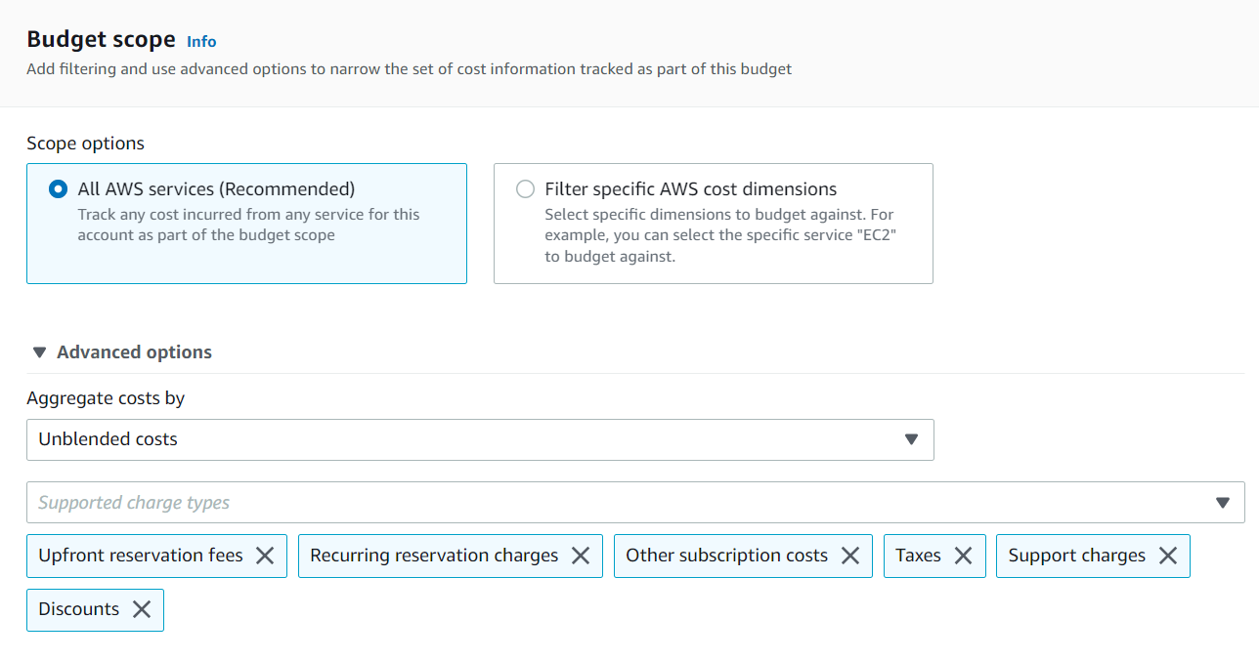

Next  


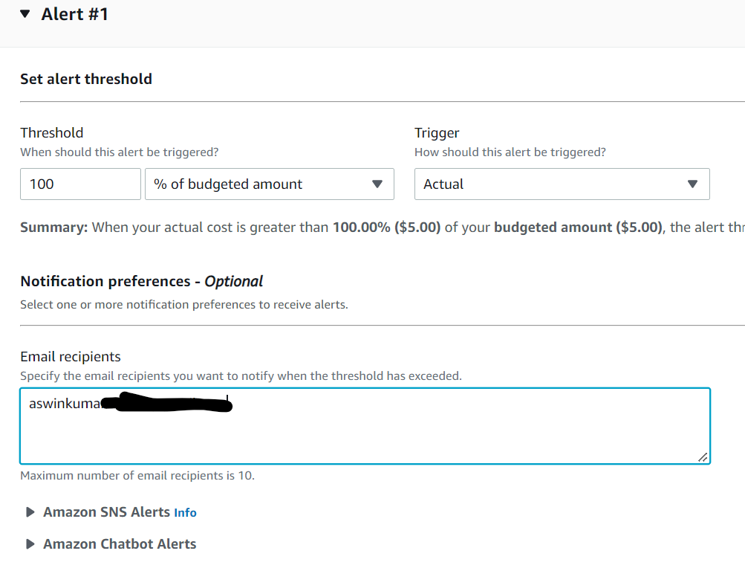

In budget actions can create action like terminate the EC2, etc. and Create budget